Hardware Report

Hardware for our project includes two PCBs to be mounted on the drone. The source for these PCBs is stored in the repository, under “/PCBs/sensor” and “/PCBs/mux”.

1. Schematic files

PDFs of the circuit schematics are included in the repository, under:
1. /PCBs/sensor/sensor_sch1.pdf
2. /PCBs/sensor/sensor_sch2.pdf
3. /PCBs/mux/mux_sch1.pdf

The source files for these schematics, as well as the routed PCBs and gerber files, are included in the same directories.

2. Development Tools

We used kicad version 4.0.7 to construct these PCBs. Kicad is a free electronics design tool available on windows, mac, and linux. It can be obtained as a binary from:
http://kicad-pcb.org/

We used the standard schematic library obtained from
https://github.com/KiCad/kicad-library
The symbols for this library are intended to work with Kicad version 4.0.x. Kicad has since upgraded to version 5.0.x with new standard library components; these components are outside the scope of this document.
This library can be installed by cloning the repository, and then setting the search path to point to the cloned “/library” directory. The path can be set in:
kicad → library editor → preferences → user defined search path → add

3. Bill of materials

The bill of materials for each board is included as a CSV exported from digikey, under:
/PCBs/sensor/digikey_bom.csv
/PCBs/mux/digikey_bom.csv

Each of these BOMs represents the components needed for one board without spares. It is recommended that when you purchase components, you buy slightly more than necessary to account for damaged or lost components during manufacturing. The OSHPark minimum board order is three copies of a board; we generally ordered parts for four.

Datasheets for these parts are available from digikey.

4. Power

Our boards are designed for a 5-volt power source, which will also power the particle photon and the NRF24L01 module when they are connected. The five volt input should be connected to each board on the pins in positions marked with the red circle below. The adjacent pin is the ground pin.
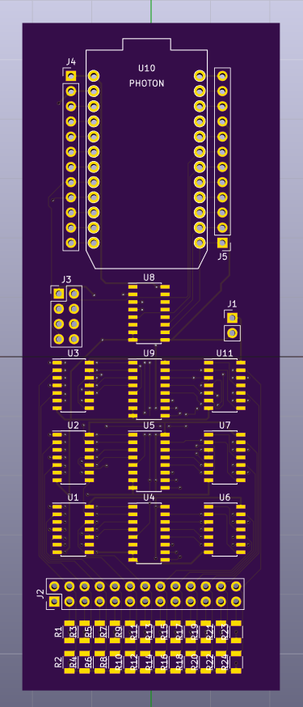
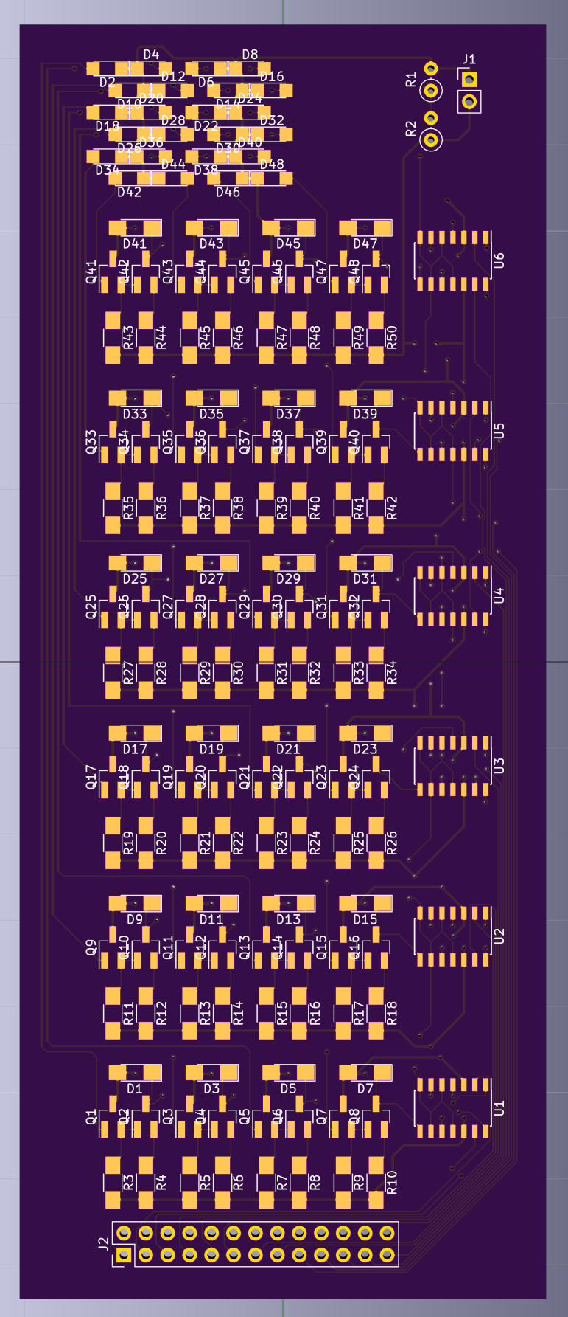
The “Sensor” board (left) has a resistor bridge next to the power input, designed to be filled with through-hole resistors. This bridge sets the sensitivity threshold of the photodiodes. The ratio of r2 / r1 should be about 3/2. Raising the value of r2 will decrease the sensitivity of the resistors, and lowering it will do the opposite.

